LAB IMPLEMENTATION EXPERIMENT 5
Data Visualization for AI Models
Generative AI Laboratory (CO1, CO2)
Aim
To implement an English-to-French translation system using the T5-small Transformer model, calculate BLEU scores by comparing generated translations with reference translations and visualize the scores through six types of plots.
Theory
T5 (Text-to-Text Transfer Transformer) is an encoder-decoder Transformer that treats many language tasks as text generation. For translation, a task prefix such as “translate English to French:” is added to the source sentence. The tokenizer converts the input text into token IDs, and the model generates the target-language sequence.
BLEU (Bilingual Evaluation Understudy) compares a generated translation with one or more reference translations using n-gram overlap and a brevity penalty. A higher BLEU score indicates stronger surface-level overlap with the reference, but BLEU does not fully measure meaning, fluency or acceptable paraphrases.
The six visualizations provide different views of the score set: a bar plot compares individual sentences, a line plot shows variation across sentence order, a scatter plot shows individual values, a histogram shows the score distribution, a box plot summarizes spread and an area plot emphasizes the trend.
Dataset note: the experiment sheet explicitly specifies English-to-French translation with T5-small and a small set of reference translations. The cricket-bat image dataset is not suitable for machine translation, so the prescribed translation sentences and reference French text are used.
Steps
1. Install PyTorch, Transformers, SacreBLEU, Matplotlib and Pandas.
2. Load the google-t5/t5-small tokenizer and sequence-to-sequence model. Select CPU or GPU based on runtime availability.
3. Prepare the English input sentences and their correct/reference French translations.
4. Prefix each input sentence with “translate English to French:” and tokenize it.
5. Generate the French translation with the T5 model and decode the generated token IDs into text.
6. Calculate a sentence-level BLEU score for each generated translation against its reference using SacreBLEU.
7. Store the English sentence, reference French sentence, generated French sentence and BLEU score in a result table.
8. Plot the BLEU scores using bar, line, scatter, histogram, box and area plots.
9. Calculate the mean sentence BLEU and corpus BLEU, then discuss differences between the generated and reference translations.
Code
Core implementation excerpt (the complete runnable workflow is provided in the corresponding notebook).
%pip -q install transformers torch sacrebleu matplotlib pandas
import torch, sacrebleu, matplotlib.pyplot as plt
from transformers import AutoTokenizer, AutoModelForSeq2SeqLM
name = "google-t5/t5-small"
device = torch.device("cuda" if torch.cuda.is_available() else "cpu")
tok = AutoTokenizer.from_pretrained(name)
model = AutoModelForSeq2SeqLM.from_pretrained(name).to(device)
english = ["Hello, how are you?", "I love artificial intelligence.",
"The weather is very good today.",
"I am a computer science student."]
reference = ["Bonjour, comment allez-vous ?",
"J'aime l'intelligence artificielle.",
"Le temps est très beau aujourd'hui.",
"Je suis étudiant en informatique."]
translations, scores = [], []
for src, ref in zip(english, reference):
prompt = "translate English to French: " + src
inputs = tok(prompt, return_tensors="pt").to(device)
with torch.no_grad():
output = model.generate(**inputs, max_new_tokens=50)
french = tok.decode(output[0], skip_special_tokens=True)
score = sacrebleu.sentence_bleu(french, [ref]).score
translations.append(french); scores.append(score)
print(src, "=>", french, "| BLEU:", round(score, 2))
# Plot the same score list as bar, line, scatter, histogram,
# box and area plots. Preserve the sentence order for x-axis plots.
x = list(range(1, len(scores)+1))
Output
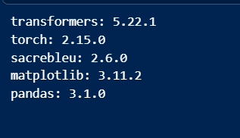

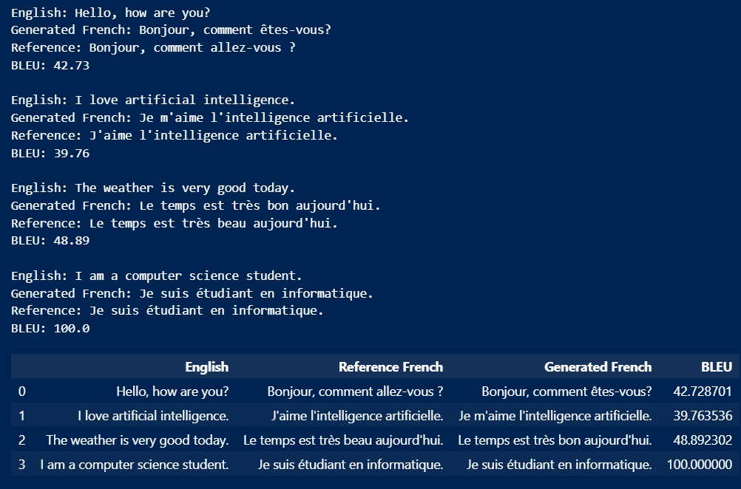

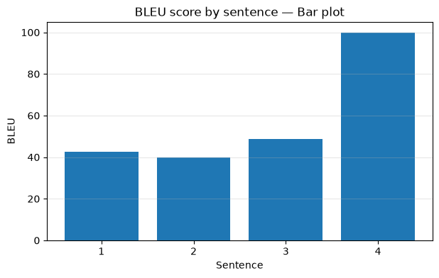
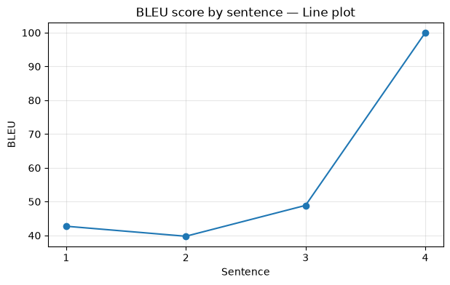

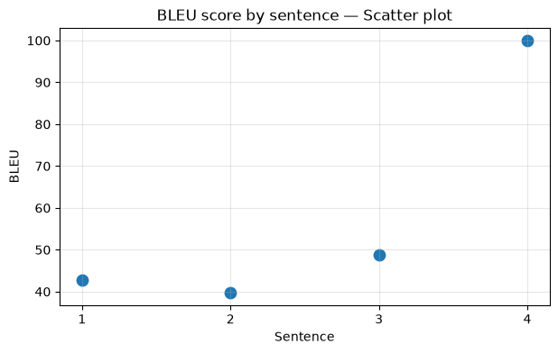
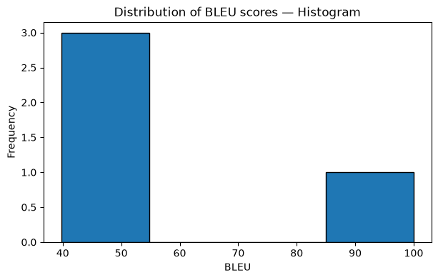

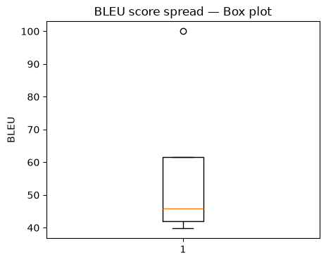
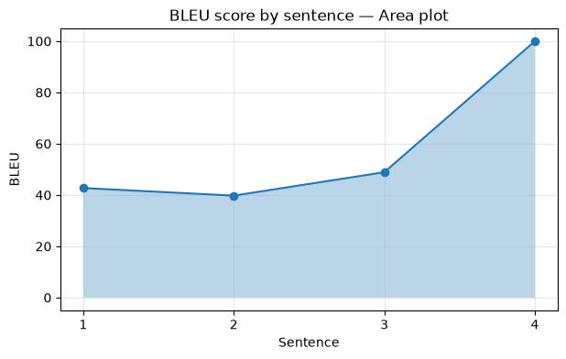

[Paste screenshot

Observation
Record the BLEU value for each sentence and the mean/corpus BLEU values from the actual run. Identify the highest- and lowest-scoring translations. Explain any cases where the translation is meaningful but receives a modest BLEU score because its wording differs from the reference.
Conclusion
The experiment demonstrates a complete text-to-text translation and evaluation pipeline using T5-small. BLEU scores summarize word-sequence overlap, while the six plots make the score distribution and sentence-level variation easier to inspect. Insert the actual score values and briefly state what the plots reveal about the translation outputs.

